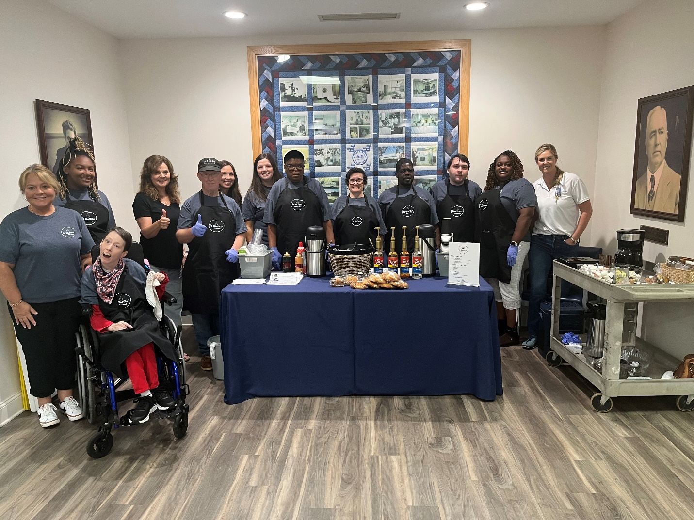
LEFT TO RIGHT: JAIME HOBBS, LORRIE SHAW, LEUNDRA RUCKER, PAM BROWN, LEE DURDEN, LAURIE JOSSEY TRUETT, ABBY MOON, STEPHANIE MAXWELL, RENEE TUCKER, TACO ARDISTER, PATRICK ARMSTRONG, KIA GIBBS, RACHEL MCCALL (photo by Sandy Adams)
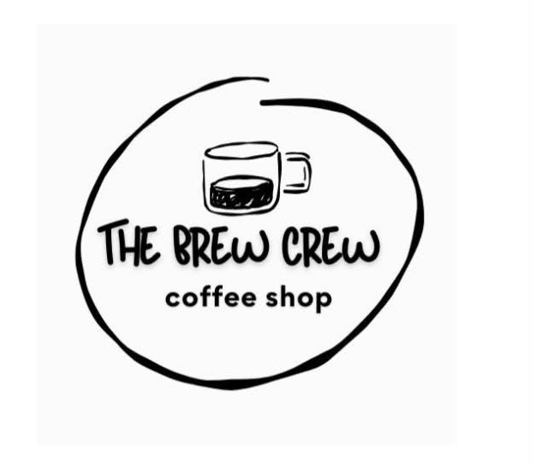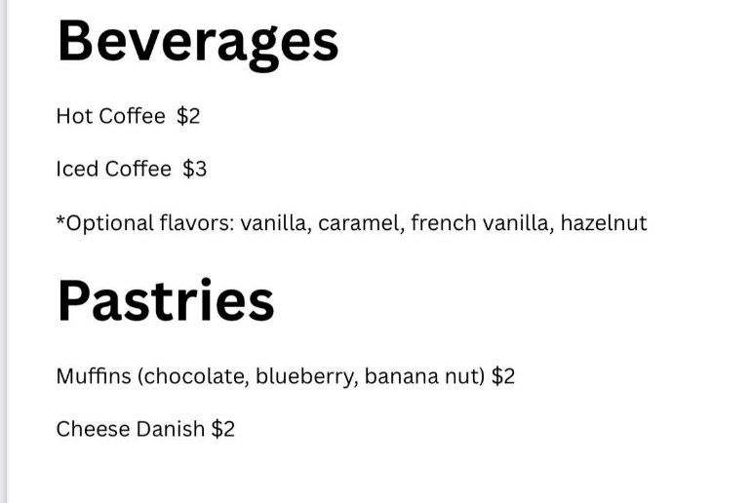
Brew Crew Coffee Shop
There is a new Coffee Shop in E town! Make plans to stop by the Elbert Memorial Hospital (EMH) main lobby for the Brew Crew Debut and pick up special treats from 9:00 until 11:00 am. Friends Helping Friends Club, Inc. (FHF Club, Inc.) is honored to support this endeavor for these inspirational entrepreneurs attending Advantage. FHF Club Founding Student President / Occupational Therapist (OT) / FHF Club, Inc. board member Abby Moon and OT Laurie Truitt instigated and organized the new adventure with Executive Director of EMH Foundation Marketing & Patient Experience Rachel McCall, FHF Club, Inc. board members Sandy Adams, Pam A. Brown, Chrystal Thomas, and Brent Moon, Shari Kaplan (GVRA), Site Supervisor Elberton IDD / Quality Community Services Advantage Behavioral Health Systems Lorrie Shaw, and EC Schools Special Education Director Kachina Rucker. A soft opening of the new Brew Crew Coffee Shop took place on Friday, May 30th (9-11am) and was a huge success selling numerous muffins and 80 cups of coffee.
School coffee shops are also provided at EC Schools. Students are provided with the opportunity to utilize skills learned for the job setting as they transition to a different age group. The program now offers next steps for EC students aging out of public school at the recently renovated Advantage buildings across the street from EMH.

In 2011, Elbert County (EC) Board of Education member P Jo Phelps approached ECCHS teacher Pam Albertson Brown with info from a school she visited in another area of the state about their coffee shop run by students with special needs. Mrs. Brown had just seen a similar coffee shop at a Christian Youth Camp (M-Fuge Camp). With like minds and divine intervention, the two contributed to form the first EC school coffee shop at ECCHS named Brewed Blessings Coffee Shop. The new business (serving an average of 70 customers each morning during its first year) forged amazing relationships with other teachers, staff, and students. Friends Helping Friends (FHF) Club student members assisted students with the new venture, volunteering their services when available, including before school and during lunch. Fast forward to today and there are currently coffee shops at the other EC schools.
EC school coffee shops are brewing confidence and serving hope in an inclusive community while celebrating the differences and unique skills evident in all students. Acknowledging each student’s ability, teachers ensure encouraging opportunities for achievement. These coffee shops are fostering productive work environments which enriches, enables, and empowers students to overcome special challenges in the work setting. Students are learning how to organize supplies, prepare and deliver their products to customers, accept payment and compute change, make lists of supplies needed, budget proceeds to purchase supplies needed, and use proceeds to sustain and grow the business. Students are taught workplace readiness traits to include soft skills that employers seek from employees. They are provided with age-appropriate knowledge and skills that will help them connect school experiences to real-life work activities and future career opportunities. Students are learning to self-advocate by developing an ability to effectively communicate, convey, negotiate, and assert their own creative ideas. Pre-employment opportunities like these are setting students up for future success.
Friends Helping Friends Club, Inc., a 501(c)3 charitable organization providing inclusive educational opportunities for EC students who have special abilities, provides equipment and supplies as needed for the coffee shops where students learn entrepreneurial skills and experience meaningful employment activities. Visit FriendsHelpingFriendsClub.com pages for more info about how this organization supports EC students throughout the year with numerous school trips, events, summer camps, school supplies, scholarships, and more.
2017 ECCHS Brewed Blessings Coffee Shop / Mrs. Pam Brown’s class with FHF Club assistants (printed in the 2017 FHF Club Yearbook): 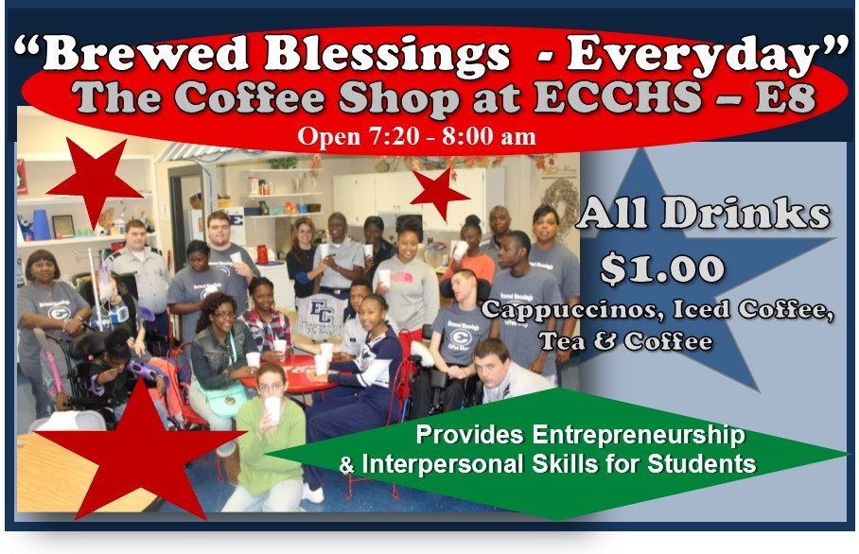
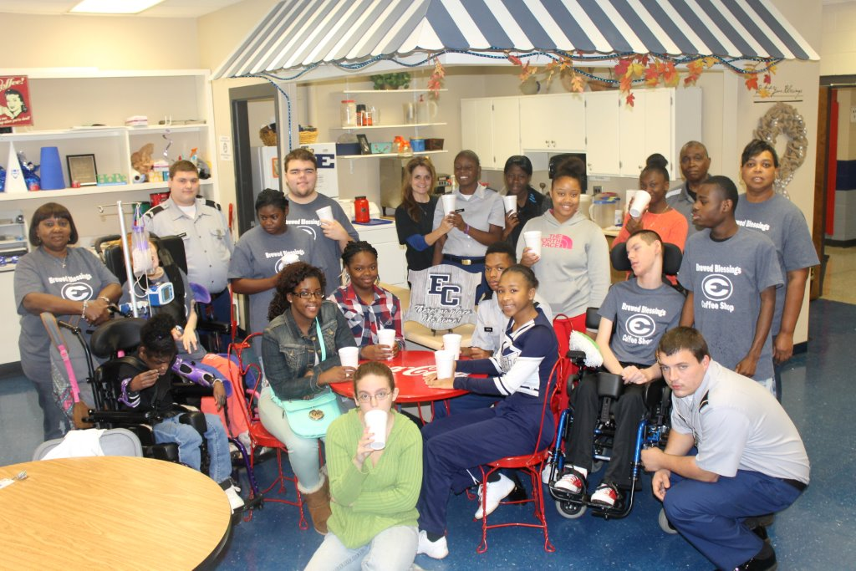
2024 EC Schools Coffee Shops
ECCHS Brewed Blessings Coffee Shop / Mrs. Kelly Hart’s & Coach Larry Kesler’s classes: 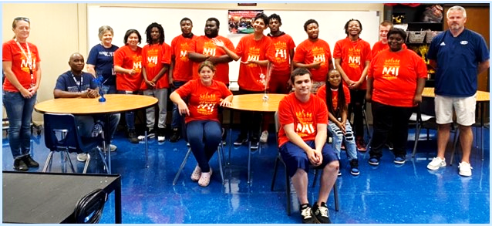

ECMS Brewed Kindness Coffee Shop / Mrs. Chrystal Thomas’ class:
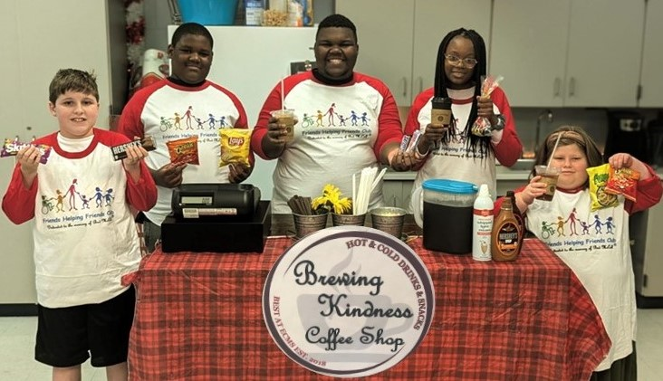
EC Elementary School Special Beans Coffee Shop / Mrs. Amy New’s class:
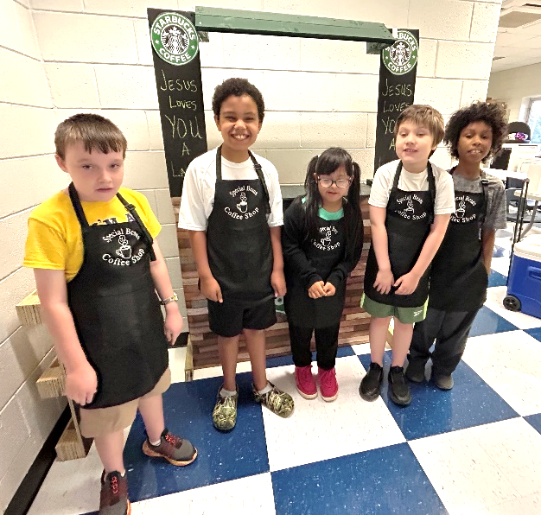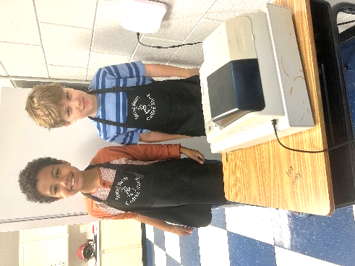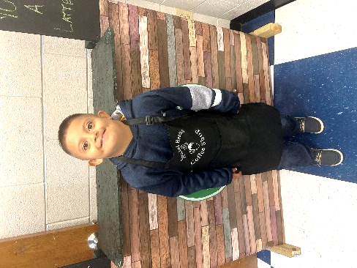

EC Primary School Special Sips Coffee Shop / Mr. Brent Moon’s & Mrs. Cara Bowen’s classes):
